Technical Bulletin: 360 SOILSCAN™ Firmware Update from Computer Using USB
December 2015

Updating your 360 SOILSCAN firmware through the 360 SOILSCAN iPad app may be extremely slow. To help make it more efficient, we’ve developed the below instructions to help you update your firmware directly through the 360 SOILSCAN machine using a USB stick and the USB port on the 360 SOILSCAN machine.

The instructions are below. If you have questions, feel free to call our Support Center at 888-512-4890.

Firmware Update Instructions

- Insert USB stick into the USB port on your computer.

- From your computer, open up your Internet browser.

- Copy https://360-cloud.mybluemix.net/soilscan-firmware/360-soilscan-fw.bin and paste into the address bar in your Internet browser to download the firmware .bin file to your computer.

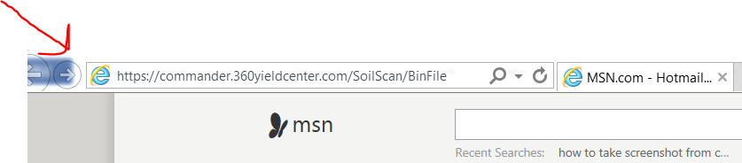

- Press Enter. A bar will appear at the bottom of the page asking, "Do you want to open or save 360-soilscan-fw.bin from commander.360yieldcenter.com?"

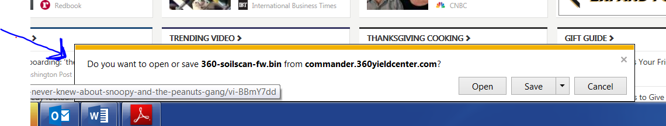

Note: Depending on the Internet browser you use, the file may appear under Downloads at the bottom of your screen. Simply click on the arrow to show the folder. Then click on it, rename it "soilscan.bin", and copy it to the USB stick. If this is the case, proceed to Step 10. If you have the pop-up that asks you to open or save, proceed to Step 5.

- Click the arrow on the Save button and select Save As.

- The 360-soilscan-fw.bin file will appear under "File name" in a new window.

- Change the File name to “soilscan”.

- Under "Save as type", select BIN File.

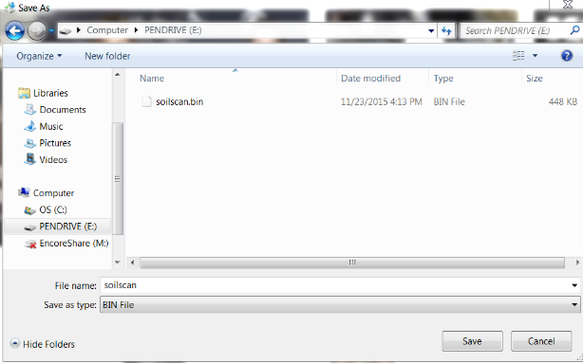

- Select the named USB stick and press the Save button. This should save your file as "soilscan.bin" to your USB stick.

- Power off your 360 SOILSCAN machine.

- Take the USB stick with the https://360-cloud.mybluemix.net/soilscan-firmware/360-soilscan-fw.bin file saved on it and plug it into the USB port on your 360 SOILSCAN machine. You can locate the USB port under the iPad holder and you may need to unplug your iPad cord.

- Turn on your 360 SOILSCAN machine. The firmware update will automatically run from the USB stick.

- Wait 20 seconds or until the 360 SOILSCAN pairs with your iPad.

- Go to Settings>Firmware Update. It should read, "You have the latest version 1.0.2."

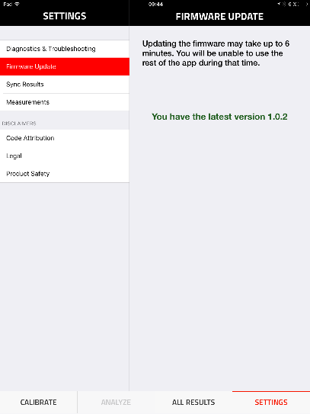

- Remove the USB stick from the USB port.

